


Korea Lunar Exploration Program
DTNPL Qualification Model
Shock Test Procedure

Date: 11 Mar. 2019 | Doc. No: KPLO-D0-550-470  Issue: D-01  Total page: 23

Superseding Revised

Reviewed By:  Chang-Soo Lee Date  DTN Product Assurance, Lumir  Kyung-Rak Lee Date  DTN System Engineer, ETRI |  | Prepared By:  Jeong-Chan Lee Date  DTN Engineer, Lumir  Dae-Soo Oh Date  DTN Project Manager, Lumir
Reviewed By:  Chol-Oh Jeong Date  DTN Product Assurance, ETRI |  | Jin-Ho Jo Date  DTN Project Leader, ETRI

Original CDMO Release__________________

Revision History
Version | Author(s) |  | Date | Description
D-01 | Jin-Ho Jo |  | 2017. 11. 07 | Draft
1.0 | Jeong-Chan Lee |  | 2019. 03.28 | QM Test Spec Updated

Documents Tree

Contents

1. Introduction 8
1.1. Purpose and Scope 8
1.2. Applicable & Reference Documents 8
1.2.1. Applicable Documents 8
1.2.1. Reference Documents 8
1.3. Abbreviations 8
2. Test Article 10
2.1. Verification Cross Reference 11
2.2. Notification for Qualification and Acceptance Tests 11
2.3. Precaution and Warnings 11
3. . Test Specifications 12
3.1. Shock 12
3.2. DTNPL Function test item 13
3.3. Test condition tolerances 13
3.4. Pass/fail criteria 13
4. Test Equipment 14
5. Shock test configuration 15
5.1. Sensor location 15
5.2. Shock test setup 16
5.2.1. Shock Test setup for x Axis 16
5.2.2. Shock Test setup for Y Axis 16
5.2.3. Shock Test setup for Z Axis 17
6. Test Environments 18
6.1. equipment to be tested 18
6.2. test location 18
6.3. Test personnel 18
7. Test Description 19
7.1. Shock test 19
8. Test Procedure 20
8.1. Shock Test For X-AXIS 20

Figures

Figure 1 DTNPL Configurations 10
Figure 2 Location for Sensors for Test 15
Figure 3 Test Configuration for X Axis 16
Figure 4 Test Configuration for Y Axis 16
Figure 5 Test Configuration for Z Axis 17
Figure 6 Shock Test Flow for DTNPL 19

Tables

Table 1 Dimension Criteria 10
Table 2 Shock Level 12
Table 3 Shock Profile(X-Y Axis) 12
Table 4 Shock Profile(Z Axis) 13
Table 5 Test Condition Tolerances 13
Table 6 Pass/Fail Criteria 13
Table 7 Shock Test Equipment List 14
Table 8 Location for Sensors for Test 15

Introduction

Purpose and Scope
This document establishes the conditions, requirements and test procedures for Shock testing of the DTNPL payload.

Applicable & Reference Documents

Applicable Documents

 | Document Number | Document Title
AD-01 | C1-SP-320-003 | Components Environmental Design and Test Specification
AD-02 | KPLO-SP-320-002 | KPLO Environmental Design and Test Specification

Reference Documents

 | Document Number | Document Title
RD-01 | MIL-STD-1540C | Test Requirements for Space Launch, Upper-Stage, and Space Vehicle
RD-02 | ECSS-E-10-0 | Space Engineering, Testing

Abbreviations

AMS | Asynchronous Message Service
BP | Bundle Protocol
BSS | Bundle Streaming Service
CCSDS | Consultative Committee for Space Data Systems
CFDP | CCSDS File Delivery Protocol
DCC | DTN Control Center
CRC | Cyclical Redundancy Check
DMA | Direct Memory Access
DTN | Delay(Disruption) Tolerant Network
DTNPL | DTN Payload
EOD | End of Data
EOF | End of File
FW | Firm Ware
FSW | Flight Software
ION | Interplanetary Overlay Network
CAS500-1 | Korea Pathfinder Lunar Orbiter
LCM | Lander Communication Model
LTP | Licklider Transmission Protocol
OBC | On Board Computer
PDHU | Payload Data Handling Unit
RCM | Rover Communication Model
DTNPL | Single Board Computer
SOD | Start of Data
SOF | Start of File
SOH | Start of Head
TBC | To Be Confirmed
TBD | To Be Defined
TC | Tele-command
TCP | Transmission Control Protocol
TM | Telemetry
UART | Universal Asynchronous Receiver Transmitter

Test Article
DTNPL is composed by major functional modules as follows :
  - SBC (Single Board Computer)
Figure 2-1 shows the DTNPL QM external view and its coordinate system. Size and mass of test article is given in Table 2-1.
The coordinate system is defined as follows.
- The plane defined by the unit coordinate system axes X and Y is parallel to the mounting surface.
- The unit Z axis is normal to the mounting plane.
- The X axis with the dimension along X (length) being greater than the dimension along Y(width).
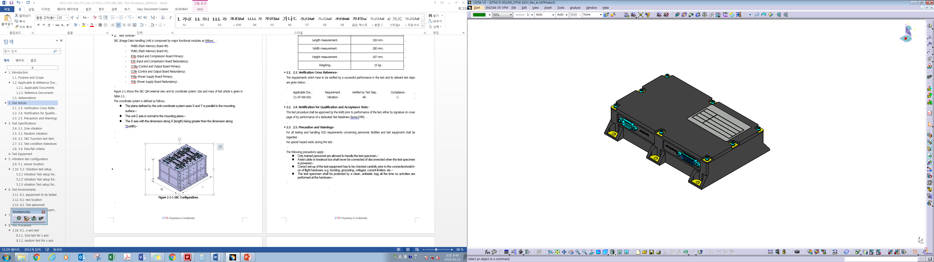
L
W
H
Figure 1 DTNPL Configurations

Table 1 Dimension Criteria
Description | Value
Length measurement | 170 mm
Width measurement | 120 mm
Height measurement | 39 mm
Weighing | 0.98 kg

Verification Cross Reference
The requirements which have to be verified by a successful performance in the test and its relevant test steps are given below:

Applicable Doc. | Requirement | Verified by Test Step | Compliance
KPLO-SP-320-002 | Shock | All | C

Notification for Qualification and Acceptance Tests
This test procedure shall be approved by the KARI prior to performance of the test, either by signature on cover page of by performance of a dedicated Test Readiness Review(TRR).

Precaution and Warnings
For all testing and handling, ESD requirements concerning personnel, facilities and test equipment shall be regarded.
No special hazard exists during the test.

The following precautions apply:
- Only trained personnel are allowed to handle the test specimen.
- A test cable or breakout box shall never be connected of disconnected when the test specimen is powered.
- Correct set-up of the test equipment has to be checked carefully prior to the connection/switch-on of flight hardware, e.g. bonding, grounding, voltages, current limiters, etc.
- The test specimen shell be protected by a clean, antistatic bag all the time no activities are performed at the hardware.

. Test Specifications

Shock
Table 3-1 is the qualification sinusoidal Shock specifications for the DTNPL in all three axes.

Table 2 Shock Level
 | In plane(X-Y) Axis |  | Out of plane (Z Axis)
Description | Freq. (Hz) | SRS (g) | Freq. (Hz) | SRS (g)
+/- Y, +/- Z  Upper Closure Wall (c) | 100 | 10 | 100 | 10
+/- Y, +/- Z  Upper Closure Wall (c) | 500 | 40 | 500 | 100
+/- Y, +/- Z  Upper Closure Wall (c) | 1300 | 100 | 1000 | 300
+/- Y, +/- Z  Upper Closure Wall (c) | 2000 | 700 | 3000 | 700
+/- Y, +/- Z  Upper Closure Wall (c) | 100000 | 700 | 1000 | 700

Table 3 Shock Profile(X-Y Axis)
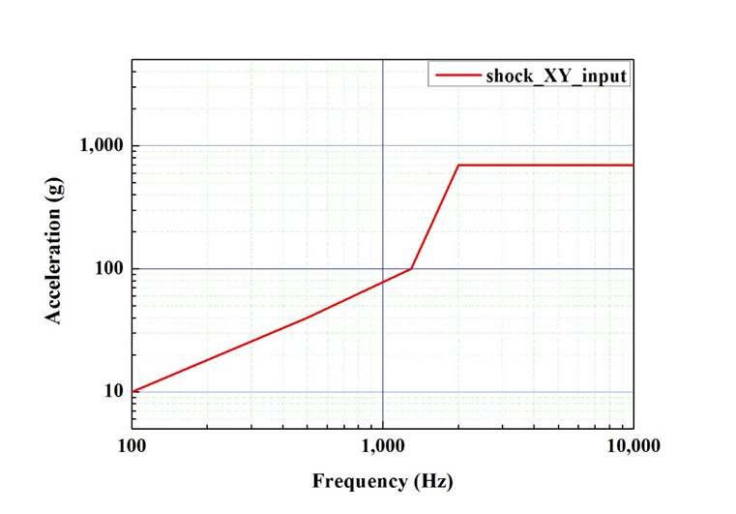

Table 4 Shock Profile(Z Axis)
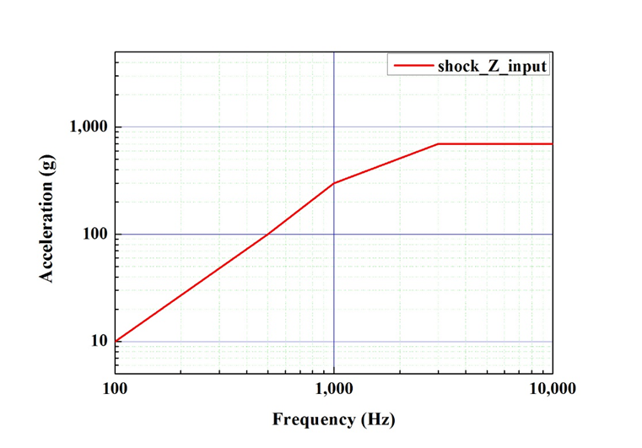

DTNPL Function test item

- Initialization
- Operation Test

Test condition tolerances

Table 5 Test Condition Tolerances
Items | Tolerances
Response Spectrum  Time History | +100%, -50%  ±10%

Pass/fail criteria
The pass/fail for the Shock test is verified by the detailed visual check, function test. The pass/fail criteria are shown in the Table 3-4.

Table 6 Pass/Fail Criteria
Item | Requirement
Function | No anomaly

Test Equipment
The Shock excitation system and data acquisition system in KARI will be used for the Shock test.
The specifications of the shaker system and data measurement system are as shown in Table 4-1.

Table 7 Shock Test Equipment List
Name | Model No. | Manufacturer
Shock Tester | TBD | KARI
Accelerometer | TBD | TBD
Test Fixture Z Axis | DTNE-MD-164003A | Lumir
Test Fixture X-Y Axis | DTNE-MD-164004A | Lumir

Shock test configuration

Sensor location
Location and information of the sensors are indicated in Figure 5-1. Normally two sensors will be attached beside mounting points and the maximum value is going to be used as criteria to know the responsive. The test sensor descriptions will be recorded on the Test Report.

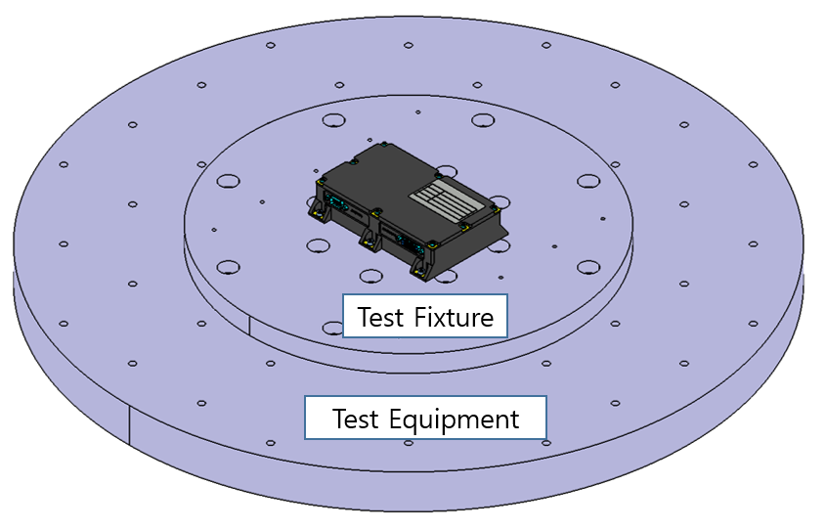
Figure 2 Location for Sensors for Test

Table 8 Location for Sensors for Test
No. | Position | Sensor S/N | Coordinate |  | Remark
No. | Position | Sensor S/N | Sensor | Equip | Remark
1 | C1(TBD) |  |  |  | Control
2 | D1(TBD) |  |  |  | Measure
3 | D2(TBD) |  |  |  | Measure
4 | D3(TBD) |  |  |  | Measure

Shock test setup

Shock Test setup for x Axis

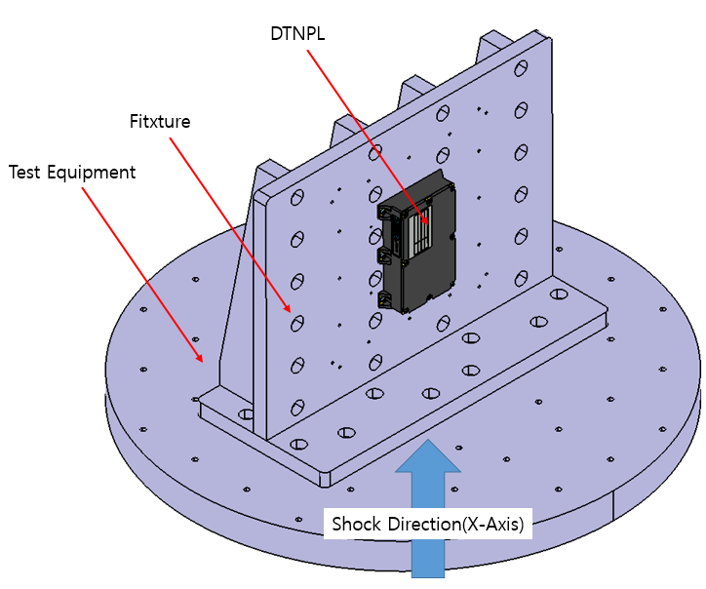
Figure 3 Test Configuration for X Axis

Shock Test setup for Y Axis

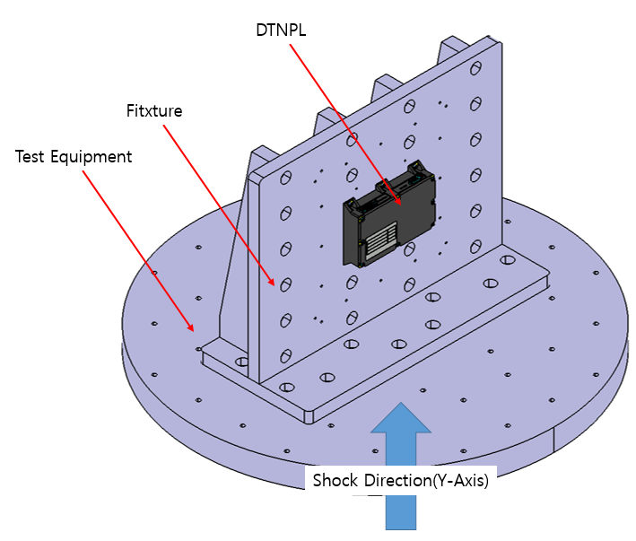
Figure 4 Test Configuration for Y Axis

Shock Test setup for Z Axis

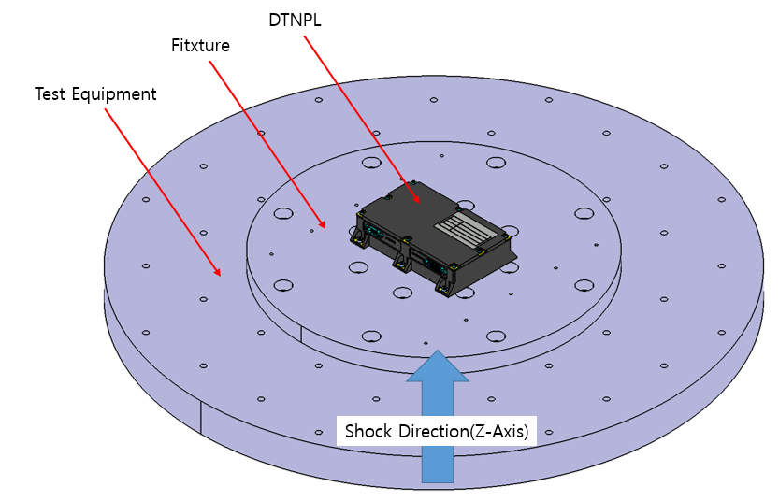
Figure 5 Test Configuration for Z Axis

Test Environments
The following test environment conditions shall be recorded prior to measurement.

equipment to be tested

Model Name:

test location

Test personnel
The personnel required for the performance of the tests is listed below:

Test Engineers
The test engineers are responsible for:
- Operation of measuring instrumentation, data acquisition, data handling, data recording
- Identification and compilation of data sheet
- Safety precaution for test articles
- Test personnel to be present in the test area
- The accuracy of the measured values & Data report

Test Manager
The test manager is responsible for:
- Test articles and technical aspects of the test performance
- Record the correct software version for test article and EGSE
- Examination of disturbances
- Test article integration and handling
- Test performance
- Evaluation of test results & Providing of test reports

Quality Assurance Engineer
The QA engineer is responsible for:
- Surveillance of test equipment according to regulations as well as the test procedure
- Statement that the test articles to be tested have passed all checks before testing
- Checking the identification markings on the test articles
- Supervision of the proceeding with respect to quality assurance performance

The customer has the fight to participate or observe the test
Responsibility | Company /Dep. | Name
Test Engineer | Lumir / R&D
Test Manager | Lumir / R&D
Quality Assurance Engineer | Lumir / PA
Facility Engineer | KARI

Test Description

Shock test
The test shall be performed in accordance with the following sequences and the test results are recorded per the indicated method.

Figure 6 Shock Test Flow for DTNPL

Test Procedure
The test will be performed in accordance with Figure 2 and Table 6.

Shock Test For X-AXIS

(a) | For the X-axis shock test, check and install the test equipment. | (√)
(b) | Assemble the test fixture and sensors.  (Refer to Figure Figure 2 and Table 8.for the sensor mounting location.) | (√)
(c) | Assemble the dummy model on the test fixture.  (Refer to Figure 3 for the mounting method and location.) | (√)
(d) | Perform the main shock test and calibrate the input data.  (It shall be performed at least three times to assure the input data.) | (√)
(e) | Disassemble the dummy model and assemble the equipment on the test fixture and inspect the test configuration.  (Refer to Figure 3 for the mounting method and location.) | (√)
(f) | Perform the main shock test in accordance with Table 2  (3 times) | (√)

Start Date / Time
End Date / Time
Temperature ℃ (23±5℃)
Relative Humidity % (60% maximum)

(g) | Generate shock response spectra for verification compliance with the spectrum level and tolerance for each channel and verify the results.  (In order to have a successful shock test, more than 50% of the spectrum shall be higher than the nominal shock profile.) | (√)
(h) | After the shock test is finished, perform the visual inspection of the equipment.  (If there is anything that does not match with the pass/fail criteria specified, the test shall be aborted.) | (√)
(i) | Test Results | (√)
(j) | Remove the equipment from the test fixture | (√)

Shock Test For Y-AXIS

(a) | For the X-axis shock test, check and install the test equipment. | (√)
(b) | Assemble the test fixture and sensors.  (Refer to Figure Figure 2 and Table 8.for the sensor mounting location.) | (√)
(c) | Assemble the dummy model on the test fixture.  (Refer to Figure 3 for the mounting method and location.) | (√)
(d) | Perform the main shock test and calibrate the input data.  (It shall be performed at least three times to assure the input data.) | (√)
(e) | Disassemble the dummy model and assemble the equipment on the test fixture and inspect the test configuration.  (Refer to Figure 4 for the mounting method and location.) | (√)
(f) | Perform the main shock test in accordance with Table 2  (3 times) | (√)

Start Date / Time
End Date / Time
Temperature ℃ (23±5℃)
Relative Humidity % (60% maximum)

(g) | Generate shock response spectra for verification compliance with the spectrum level and tolerance for each channel and verify the results.  (In order to have a successful shock test, more than 50% of the spectrum shall be higher than the nominal shock profile.) | (√)
(h) | After the shock test is finished, perform the visual inspection of the equipment.  (If there is anything that does not match with the pass/fail criteria specified, the test shall be aborted.) | (√)
(i) | Test Results | (√)
(j) | Remove the equipment from the test fixture | (√)

Shock Test For Z-AXIS

(a) | For the X-axis shock test, check and install the test equipment. | (√)
(b) | Assemble the test fixture and sensors.  (Refer to Figure Figure 2 and Table 8.for the sensor mounting location.) | (√)
(c) | Assemble the dummy model on the test fixture.  (Refer to Figure 3 for the mounting method and location.) | (√)
(d) | Perform the main shock test and calibrate the input data.  (It shall be performed at least three times to assure the input data.) | (√)
(e) | Disassemble the dummy model and assemble the equipment on the test fixture and inspect the test configuration.  (Refer to Figure 6 for the mounting method and location.) | (√)
(f) | Perform the main shock test in accordance with Table 2  (3 times) | (√)

Start Date / Time
End Date / Time
Temperature ℃ (23±5℃)
Relative Humidity % (60% maximum)

g) | Generate shock response spectra for verification compliance with the spectrum level and tolerance for each channel and verify the results.  (In order to have a successful shock test, more than 50% of the spectrum shall be higher than the nominal shock profile.) | (√)
(h) | After the shock test is finished, perform the visual inspection of the equipment.  (If there is anything that does not match with the pass/fail criteria specified, the test shall be aborted.) | (√)
(i) | Test Results | (√)
(j) | Remove the equipment from the test fixture | (√)

9. Test conclusions
The PA shall review the test data for acceptance of the Shock test.
The following sign off is verification that the test article has satisfactorily passed Shock test.

PA: Date:

